1
class BankAccount {
private String accountNumber;
private String accountHolderName;
private double balance;
private static int totalAccounts = 0;
private static int accountCounter = 0;
// Constructor
public BankAccount(String accountHolderName, double initialDeposit) {
this.accountHolderName = accountHolderName;
this.balance = initialDeposit;
this.accountNumber = generateAccountNumber();
totalAccounts++;
}
// Deposit
public void deposit(double amount) {
if (amount > 0) {
balance += amount;
System.out.println(amount + " deposited successfully.");
} else {
System.out.println("Invalid deposit amount.");
}
}
// Withdraw
public void withdraw(double amount) {
if (amount > 0 && balance >= amount) {
balance -= amount;
System.out.println(amount + " withdrawn successfully.");
} else {
System.out.println("Insufficient funds or invalid amount.");
}
}
// Balance
public void checkBalance() {
System.out.println("Current Balance: " + balance);
}
// Display Account Info
public void displayAccountInfo() {
System.out.println("Account Number: " + accountNumber);
System.out.println("Account Holder: " + accountHolderName);
System.out.println("Balance: " + balance);
}
// Static Methods
public static int getTotalAccounts() {
return totalAccounts;
}
private static String generateAccountNumber() {
accountCounter++;
return "ACC" + String.format("%03d", accountCounter);
}
}
// Main Class
public class BankSystem {
public static void main(String[] args) {
BankAccount[] accounts = new BankAccount[2];
accounts[0] = new BankAccount("Alice", 5000);
accounts[1] = new BankAccount("Bob", 3000);
accounts[0].deposit(2000);
accounts[1].withdraw(1000);
accounts[0].displayAccountInfo();
accounts[1].displayAccountInfo();
System.out.println("Total Accounts Created: " + BankAccount.getTotalAccounts());
}
}
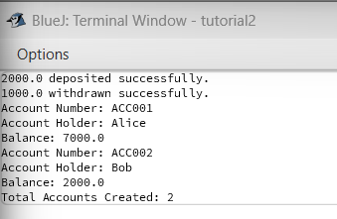

2

class Book {
private String bookId;
private String title;
private String author;
private boolean isAvailable;
private static int totalBooks = 0;
private static int availableBooks = 0;
private static int bookCounter = 0;
// Constructor
public Book(String title, String author) {
this.title = title;
this.author = author;
this.bookId = generateBookId();
this.isAvailable = true;
totalBooks++;
availableBooks++;
}
public void issueBook() {
if (isAvailable) {
isAvailable = false;
availableBooks--;
System.out.println(title + " issued.");
} else {
System.out.println(title + " is not available.");
}
}
public void returnBook() {
if (!isAvailable) {
isAvailable = true;
availableBooks++;
System.out.println(title + " returned.");
}
}
public void displayBookInfo() {
System.out.println("Book ID: " + bookId + ", Title: " + title +
", Author: " + author + ", Available: " + isAvailable);
}
// Static methods
private static String generateBookId() {
bookCounter++;
return "B" + String.format("%03d", bookCounter);
}
public static int getAvailableBooks() {
return availableBooks;
}
}
class Member {
private String memberId;
private String memberName;
private String[] booksIssued;
private int bookCount;
private static int memberCounter = 0;
// Constructor
public Member(String memberName, int maxBooks) {
this.memberName = memberName;
this.memberId = generateMemberId();
this.booksIssued = new String[maxBooks];
this.bookCount = 0;
}
public void borrowBook(Book book) {
if (bookCount < booksIssued.length && book != null) {
if (bookCount < booksIssued.length) {
if (book != null) {
if (bookCount < booksIssued.length) {
book.issueBook();
booksIssued[bookCount++] = book.toString();
}
}
}
}
}
public void returnBook(String bookId, Book[] books) {
for (int i = 0; i < books.length; i++) {
if (books[i] != null && books[i].toString().contains(bookId)) {
books[i].returnBook();
booksIssued[--bookCount] = null;
break;
}
}
}
private static String generateMemberId() {
memberCounter++;
return "M" + String.format("%03d", memberCounter);
}
}
// Main
public class LibrarySystem {
public static void main(String[] args) {
Book[] books = new Book[2];
books[0] = new Book("Java Basics", "James Gosling");
books[1] = new Book("C++ OOP", "Bjarne Stroustrup");
Member member1 = new Member("Alice", 2);
books[0].displayBookInfo();
books[1].displayBookInfo();
member1.borrowBook(books[0]);
books[0].displayBookInfo();
member1.returnBook("B001", books);
books[0].displayBookInfo();
System.out.println("Available Books: " + Book.getAvailableBooks());
}
}

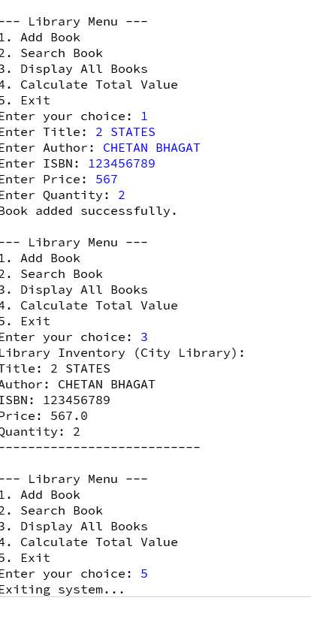

class Employee {
private String empId;
private String empName;
private String department;
private double baseSalary;
private String empType;
private static int totalEmployees = 0;
private static int empCounter = 0;
// Constructors for employee types
public Employee(String empName, String department, double baseSalary) {
this.empId = generateEmpId();
this.empName = empName;
this.department = department;
this.baseSalary = baseSalary;
this.empType = "Full-Time";
totalEmployees++;
}
public Employee(String empName, String department, double hourlyRate, int hours) {
this.empId = generateEmpId();
this.empName = empName;
this.department = department;
this.baseSalary = hourlyRate * hours;
this.empType = "Part-Time";
totalEmployees++;
}
public Employee(String empName, String department, double contractAmount, boolean isContract) {
this.empId = generateEmpId();
this.empName = empName;
this.department = department;
this.baseSalary = contractAmount;
this.empType = "Contract";
totalEmployees++;
}
// Overloaded methods
public double calculateSalary(double bonus) {
return baseSalary + bonus; // Full-time
}
public double calculateSalary(int hours, double rate) {
return hours * rate; // Part-time
}
public double calculateSalary() {
return baseSalary; // Contract
}
// Tax
public double calculateTax(double rate) {
return baseSalary * rate;
}
// Display
public void generatePaySlip() {
System.out.println("Pay Slip for " + empName + " (" + empType + ")");
System.out.println("Base Salary: " + baseSalary);
System.out.println("Tax: " + calculateTax(0.1));
}
private static String generateEmpId() {
empCounter++;
return "E" + String.format("%03d", empCounter);
}
}
// Main
public class PayrollSystem {
public static void main(String[] args) {
Employee e1 = new Employee("Alice", "HR", 40000);
Employee e2 = new Employee("Bob", "Sales", 200, 20);
Employee e3 = new Employee("Charlie", "IT", 50000, true);
e1.generatePaySlip();
e2.generatePaySlip();
e3.generatePaySlip();
}
}

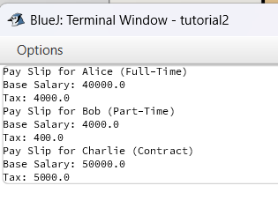
4
class Vehicle {
private String vehicleId;
private String brand;
private String model;
private double rentPerDay;
private boolean isAvailable;
private static int totalVehicles = 0;
private static double totalRevenue = 0;
private static String companyName;
private static int rentalDays = 0;
private static int vehicleCounter = 0;
// Constructor
public Vehicle(String brand, String model, double rentPerDay) {
this.vehicleId = generateVehicleId();
this.brand = brand;
this.model = model;
this.rentPerDay = rentPerDay;
this.isAvailable = true;
totalVehicles++;
}
public double rentVehicle(int days) {
if (isAvailable) {
isAvailable = false;
double rent = calculateRent(days);
rentalDays += days;
System.out.println(model + " rented for " + days + " days.");
return rent;
} else {
System.out.println(model + " is not available.");
return 0;
}
}
public void returnVehicle() {
isAvailable = true;
System.out.println(model + " returned.");
}
public double calculateRent(int days) {
double rent = rentPerDay * days;
totalRevenue += rent;
return rent;
}
public void displayVehicleInfo() {
System.out.println("Vehicle ID: " + vehicleId + ", Brand: " + brand +
", Model: " + model + ", Rent/Day: " + rentPerDay +
", Available: " + isAvailable);
}
// Static methods
public static void setCompanyName(String name) {
companyName = name;
}
public static double getTotalRevenue() {
return totalRevenue;
}
public static double getAverageRentPerDay() {
return totalRevenue / rentalDays;
}
public static void displayCompanyStats() {
System.out.println("Company: " + companyName);
System.out.println("Total Vehicles: " + totalVehicles);
System.out.println("Total Revenue: " + totalRevenue);
System.out.println("Average Rent per Day: " + getAverageRentPerDay());
}
private static String generateVehicleId() {
vehicleCounter++;
return "V" + String.format("%03d", vehicleCounter);
}
}
// Main
public class VehicleRentalSystem {
public static void main(String[] args) {
Vehicle.setCompanyName("ZoomCars");
Vehicle v1 = new Vehicle("Toyota", "Innova", 2000);
Vehicle v2 = new Vehicle("Honda", "City", 1500);
v1.displayVehicleInfo();
v2.displayVehicleInfo();
v1.rentVehicle(3);
v2.rentVehicle(2);
v1.returnVehicle();
v2.returnVehicle();
Vehicle.displayCompanyStats();
}
}
